研究报告
Research Report
红花种质性状关联和路径分析
Belete Semahegn Yared , Tesfaye Misteru
Holetta Research Center, Ethiopian Institute of Agricultural Research, P.O.Box 2003, Addis Ababa, Ethiopia
通讯作者: yaredsemahegnb@gmail.com; 作者
植物药与药理学杂志, 2012 年, 第 1 卷, 第 2 篇 doi: 10.5376/jpmp.cn.2016.05.0007
收稿日期：2016 年 07 月 18 日
接受日期：2016 年 07 月 24 日
发表日期：2016 年 08 月 15 日
本文首次发表在《Molecular Plant Breeding》(2016, Vol.7, No.31)上。现依据版权所有人授权的许可协议，采用Creative Commons Attribution License对其进行授权，再次发表与传播。只要对原作有恰当的引用，版权所有人允许并同意第三方无条件的使用与传播。建议最佳引用格式：
引用格式(中文)：
Belete和Tesfaye, 2016, 红花种质性状关联和路径分析, 植物药与药理学杂志(online) Vol.5 No.7 pp.1-5 (doi: 10.5376/jpmp.cn.2016.05.0007)
引用格式(英文)：
Belete, and Tesfaye, 2016, Stan Characters Associations and Path Analysis in Safflower (Carthamus tinctorious) Accessions, Zhiwuyao Yu Yaolixue Zazhi (online) Vol.5 No.7 pp.1-5 (doi: 10.5376/jpmp.cn.2016.05.0007)

摘 要 红花作为一个潜在的油料作物，可以用来替代埃塞俄比亚现有广泛种植的油料作物，它需要依赖于其组成特点来提高种子产量。检查性状关联及其相互关系有助于选育提高种子产量等复杂性状的育种材料。2012年，我们在种植季节进行了研究，以确定该性状关联和分区关联对红花种子产量造成的直接和间接的影响。相关系数分析表明，种子产量记录与开花(0.190)，株高(0.234)，头状花序的数量(0.172)、单株粒数(0.834)和百粒重(0.197)明显呈正相关。路径系数分析的描述显示每株种子数(0.89)具有最高的直接正效应，其次是百粒重(0.106)。这项研究表明，每株种子的数量是最重要的产量要素，其次是种子重量。因此，这表明，建立在这些形状上的直接选育将有效提高红花产量。

关键词 种质, 相关系数, 路径系数, 红花, 种子产量

Stan Characters Associations and Path Analysis in Safflower (Carthamus tinctorious) Accessions
Belete Semahegn Yared , Tesfaye Misteru
Holetta Research Center, Ethiopian Institute of Agricultural Research, P.O.Box 2003, Addis Ababa, Ethiopia

Corresponding author, yaredsemahegnb@gmail.com; Authors

Abstract Safflower as a potential oil crops which can be used as an alternative to the existing widely cultivated oil crops in Ethiopia needs seed yield improvement which inturn relies on its component characters. Examining character association and their interrelationships is helpful in selecting the breeding material for improving the complex trait such as seed yield. A study was carried out during 2012 cropping season to determine the associations of characters and partition of this association into direct and indirect effects on seed yield of safflower. Correlation coefficient analysis showed that seed yield recorded significant positive association with days to flowering (0.190), plant height (0.234), number of capitula (0.172), number of seed per plant (0.834) and hundred seed weight (0.197). The highest positive direct effect was revealed by number of seed per plant (0.89) followed by hundred seed weight (0.106) as depicted by path coefficient analysis. This study showed that number of seed per plant is the most important yield component followed by seed weight. Therefore, this suggests that direct selection based on these characters would be effective for the improvement of safflower.

Keywords Accessions; Correlation coefficient; Path coefficient; Safflower; Seed yield
红花(Carthamus tinctorious L., 2n＝24)，菊科，主要栽培将其种子用于制作植物油和鸟食(Lie and Mundel, 1996; Yadava et al., 2012)。传统上，它被用于食品着色，织物绘画，蔬菜和药物(McGuire et al., 2012)。它也可以替代干草或青贮(Smith, 1996)，同时它还是一种埃塞俄比亚和苏丹的小吃(Belayneh and Wolde Mariam，1991)。红花作为一种油料作物，在埃塞俄比亚和印度都具有悠久的栽培历史(Weiss，2000)，在埃塞俄比亚当地被称为“suff”(Ashri, 1957; Smith, 1996)。尽管有所争议，埃塞俄比亚还是被提议作为红花发展的主要中心(Vavilov, 1951)。埃塞俄比亚是第四个世界领先的红花生产国，仅次于印度、美国、墨西哥(Yadava et al., 2012)。在埃塞俄比亚，根据CSA(2008/9)数据显示，它的种植面积达到7 853公顷，以每公顷0.9吨的产量计算，它的产量有6 581.4吨。作物有在不同条件下生长的巨大潜力(Golkar, 2014)。红花是一种拥有发达根系能从地下深层土壤中吸取水分的长期作物。它具有耐干耐热的特性，可在干旱和半干旱地区种植(Lie and Mundel, 1996)。尽管它有很大的价值，它的生产却被局限于埃塞俄比亚，这或许是由于缺乏作物意识和相对较低的生产力及研究关注。尽管如此，红花在埃塞俄比亚作为一种替代油料作物仍然十分重要。为了提高红花的生产和生产效率，应对作物产量的提高给予适当的关注。
由于产量是一个复杂的性状，在努力改进的过程中，确定组成性状的关系，以及因果关系是间接选择提高红花的产量潜力必不可少的 (Singh, 1991; Consentino et al., 1997; Patil, 1998; Omidi, 2001; Mahasi et al., 2006; Mozaffari and Asadi, 2006; Ahmadzadeh et al., 2012)。研究表明，红花中单株穗数与种产量呈显著正相关(Nezhad and Talebi, 2015; Shinwari et al., 2014)。Ahmadzadeh(2013)报道称，单穗种子数和种产量之间显著正相关。他还表明，单穗种子的数量对红花的种产量有直接的正面影响。这项研究主要是为了确定性状的关联，以及鉴别这些性状对红花产量的直接和间接的影响。
1结果与分析
经测量的性状关联已被记录(表1)。记录显示种子产量与开花天数(0.190)、株高(0.234)，头状花序数(0.172)和百粒重(0.197)之间存在显著正相关。株高、头状花序和百粒重之间得到了相似的结果(Omidi, 1994; Johnson et al., 2001; Omidi, 2001; Arslan, 2007; Omidi et al., 2009; Ahmadzadeh, 2013)。种产量和单株粒数(0.834)呈正相关。株高和分枝数(0.307)，头状花序数(0.518)及单株粒数(0.309)呈显著正相关。分枝数与头状花序数(0.547)呈正相关。头状花序数与单株粒数(0.321)呈显著相关。研究还显示，头状花序数与单花序种子数(0.177)之间呈正相关，这与Consentino等人的研究结果一致(1997)。单花序种子数和单株粒数(0.231)也呈正相关。在本研究中，种质性状的相关性可能是基因的多效性作用的结果，也可能是自然选择(Falconer，1986)的压力作用的结果。
表1 2012年种植季红花162个品种的性状组合
Table 1 Characters association of 162 Safflower accessions during 2012 cropping season
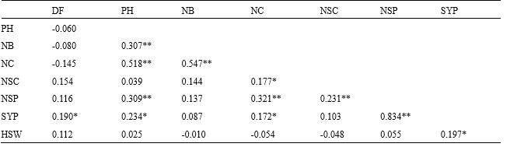
注: *, **分别在P≤0.05和P≤0.01的显著水平; DF: 开花天数; PH: 株高; NB: 分枝数; NC: 头状花序数; NSC:单花序种子数;NSP: 单株粒数; SYP: 单株种子产量; HSW: 百粒重
Note: *, ** significant at p≤0.05 and p≤0.01 level, respectively; DF: Days to flowering; PH: Plant height; NB: Number of branches; NC: Number of capitula; NSC: Number of seed per capitula; NSP: Number of seed per plant; SYP: Seed yield per plant; HSW: Hundred seed weight
分路径分析表明，开花期、株高、分枝数、单株粒数和百粒重对红花的种产量有直接的积极影响，而头状花序，单花序种子数产生直接的负效应(表2)。记录显示，单株种子数和百粒重对种子产量有最高的正向直接影响。因此，以提高红花的种子产量为选择标准考虑这些性状将是值得的。类似的结果也有过报道(Eslam et al., 2010; Ahmadzadeh et al., 2012)。还有报道称百粒重具有高度的正面直接效应(Mahasi et al., 2006; Patil et al, 1994; Ashri et al., 1976; Uslu et al., 1997; Lahane et al., 1999)，单株头状花序是产量构成中最重要的部分。在这项研究中，种子产量与头状花序数呈正相关是通过单株粒数这一特性的间接影响的结果，这是最重要的产量构成中所描绘的路径分析。
表2 7个性状对红花种子产量的间接和间接影响
Table 2 The direct (diagonal) and the indirect effects of the 7 characters on seed yield of safflower accessions
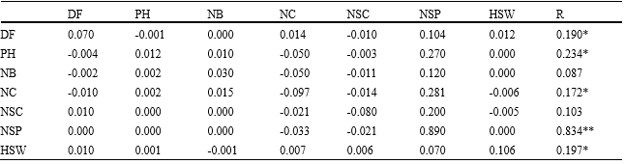
注: *, **分别在P≤0.05和P≤0.01的水平; DF: 开花天数; PH: 株高; NB: 分枝数; NC: 头状花序数; NSC: 单花序种子数; NSP: 单株粒数; HSW: 百粒重; r: 单株种子产量的相关性
Note: *, ** significant at p≤0.05 and p≤0.01 level, respectively; DF: Days to flowering; PH: Plant height; NB: Number of branches; NC: Number of capitula; NSC: Number of seed per capitula; NSP: Number of seed per plant; HSW: Hundred seed weight; r: correlation with seed yield per plant
2材料与方法
这项研究是在Holetta农业研究中心(东经38°，北纬9°)进行的，在2012种植季期间，使用了160种红花和两种对照标准，不带刺的图尔卡纳种质和带刺的当地种质；从生物多样性研究所得到的埃塞俄比亚种质，其中96.9%是带刺的(表3)。我们利用增强设计进行了实验研究。每个种质播种在两排长0.5米，间距0.3米的地块上。其他栽培试验均按要求进行。每种种质随机抽取十株来确定表型性状如开花期，株高(cm)，单株分枝数、单株的头状花序，单花序种子数、单株粒数、单株种子产量(g)和百粒重(g)。使用agrobasetm统计软件确定了皮尔森相关系数(agronomix软件有限公司，加拿大)。路径分析则是根据Dewey和Lu(1959)提出的方法进行。
表3研究中各种质的来源和特性
Table 3 Origin and characters of each accession under study
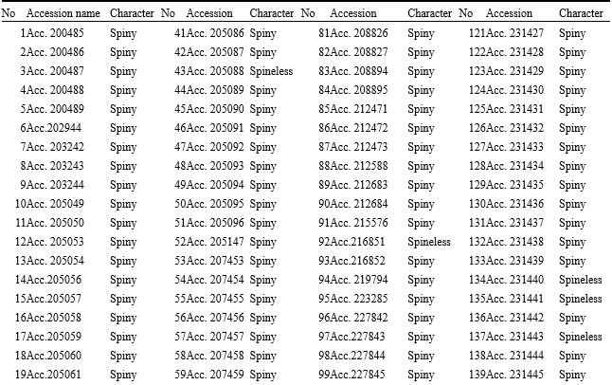
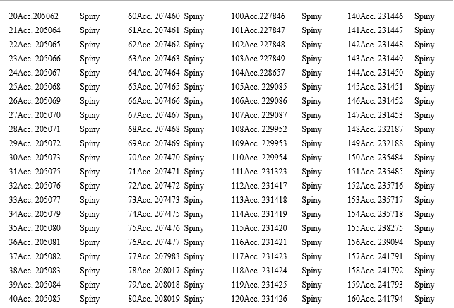
作者贡献
第一作者完成了对数据的分析和解释以及手稿的解释，第二作者对概念、设计和数据的获取以及最终稿的修改做出了实质性的贡献。
致谢
作者对高原石油作物商品研究技术人员为收集本实验的数据做出的贡献表示感谢。
参考文献
B Ahmadzadeh A.R., Alizadeh B., Shahryar H.A. and Narimani-Rad M., 2012, Path analysis of the relationships between grain yield and some morphological characters in spring safflower (Carthamus tinctorius L.) under normal irrigation and drought stress condition, J. Med. Plants Res, 6: 1268-1271
http://dx.doi.org/10.5897/jmpr11.1327
Ahmadzadeh A., 2013, Genetic diversity and classification of spring safflower (Carthamus tinctorius) cultivars using morphological characters, Adv. Biores, 4: 125-131
Omidi A.H., Khazaei H. and Hongbo S., 2009, Variation for Some Important Agronomic Traits in 100 Spring Safflower (Carthamus tinctorius L.) Genotypes, American-Eurasian J. Agric. & Environ. Sci, 5: 791-795
Arslan B., 2007, The path analysis of yield and its components in safflower (Carthamus tinctorius), Asian J. Biological Sci, 7: 668-672
http://dx.doi.org/10.3923/jbs.2007.668.672
Ashri A., 1957, Cytogenetics and morphology of Carthamus L. species and hybrids. PhD Dissertation, Univ Califor¬nia, Davis CA USA
Ashri A., Zimmer E., Urie L. and Ghaner A., 1976, Evaluation of the world collection of safflower for yield and yield components and their relationship, Crop Sci, 14: 799-802
http://dx.doi.org/10.2135/cropsci1974.0011183X001400060006x
Belayneh H. and Wolde-Mariam Y., 1991, Safflower production, utilization and research in Ethiopia in Proceedings Second International Safflower Conference, Hyderabad, India, 9-13 Jan. 1989 (V. Ranga Rao and M. Ramachandran, eds.). Indian Society of Oilseeds Research, Directorate of Oilseeds Research, Hyderabad, India, pp. 43-55
Consentino S., Copani V. and Camarata M., 1997, Relations between meteorological parameters yield and seed oil content in safflower in Mediterranean environment. IV International Safflower Conference, Italy, pp. 149-155
CSA, 2008/09, Agricultural sample survey: Report on area and production of major crops. Volume I, Central Statistical Agency (CSA) of the Federal Democratic Republic of Ethiopia, Addis Ababa, Ethiopia
Dewey D.R. and Lu K.H., 1959, A correlation and path coefficient analysis of components of crested wheat grass seed production, Agron J, 51:515-518
http://dx.doi.org/10.2134/agronj1959.00021962005100090002x
Eslam B.P., Monirifar H. and Ghassemi M.T., 2010, Evaluation of late season drought effects on seed and oil yields in spring safflower genotypes, Turk. J. Agri, 34: 373-380
Falconer D.S., 1981, Introduction to quantitative genetics 2nd Edn., John Wiley and Sons, Inc., New York, UK, pp. 281-294
Johnson R.C., Ghorpade P.B. Bradley V.L., and Mundel H.H, 2001, Evaluation of the USDA core safflower collection for seven quantitative traits. V International safflower conf., USA, pp.143-149
Lahane P.S., Mukewar A.M., Zope J.S., Kalpande H.V. and Kalpande V.V., 1999, Genetic variability for different traits in safflower (Carthamus tinctorius L.), J. Soil Crops, 9: 130-132
Li D. and Mündel H.H., 1996, Safflower, Carthamus tinctorius L. Promoting the conservation and use of underutilized and neglected crops, 7 Institute of Plant Genetics and Crop Plant Research, Gatersleben/International Plant Genetic Resources Institute, Rome, Italy
Mahasi M.J., Pathak R. S., Wachira F. N., Riungu T.C., Kinyua M. G. and Kamundia J. W., 2006, Correlation and path coefficient analysis in exotic safflower (Carthamus tinctorius L.) genotypes tested in the arid and semi arid lands (Asals) of Kenya, Asian J. Plant Sci, 5: 1035-1038
http://dx.doi.org/10.3923/ajps.2006.1035.1038
McGuire P.E., Damania A.B. and Qualset C.O., 2012, Safflower in California, The Paulden F. Knowles personal history of plant exploration and research on evolution, genetics, and breeding, Agronomy Progress Report No. 313, Dept. of Plant Sciences. University of California, Davis CA, USA
Mozaffari K. and Asadi A. K., 2006, Relationships among traits using Correlation, principal components and path analysis in safflower mutants sown in irrigated and drought stress conditioa, Asian J. Plant Sci, 5: 977-983
http://dx.doi.org/10.3923/ajps.2006.977.983
Nezhad T.H. and Talebi R., 2015, Interrelationships between agronomic traits with seed yield in safflower (Carthamus tinctorius L.) under different irrigation regimes, Biol. Forum Int. J., 7(2): 430-435
Omidi A.H., 2001, Correlation between traits and path analysis for grain and oil yield in spring safflower. Proceeding of the V International Safflower Conference, July, 23-27, USA, pp. 95-98
Omidi A.H., 1994, Evaluation of safflower genotypes for yield and yield components. Second Iranian Congress on crop production and breeding, Karaj-Iran
Patil H.S., 1998, Genetic variability, association and path analysis in safflower, Indian J. Agric. Res, 23: 46-50
Patil V.D., Reddy M.V.S. and Nerkar Y.S., 1994, Efficiency of early generation selections for yield and related characters in safflower (Carthamus tinctorius L.), Theor, Appl. Genet, 89:293-296
http://dx.doi.org/10.1007/bf00225157
Golkar P., 2014, Breeding improvements in safflower (Carthamus tinctorius L.): A review AJCS, 8:1079-1085
Shinwari Z.K., Rehman H., and Rabbani M.A., 2014, Morphological traits based genetic diversity in safflower (Carthamus tinctorius L.), Pak. J. Bot., 46(4): 1389-1395
Singh M., 1991, Genotypic and phenotypic correlation in plant traits. Computer Service, ICARDA, Aleppo, Syria, pp. 279
Smith J.R., 1996, Safflower. AOCS Press, Champaign, IL, USA
http://dx.doi.org/10.1201/9781439832080
Uslu N., A. Akin and M. Basi, 1997, Weed and row spacing effects on some agronomic characters of safflower spring planted. IV International conf., Italy, pp. 128-132
Vavilov N.I., 1951, The origin, variation, immunity and breeding of cultivated plants. [Transl. K.S. Chester] in: Selected Writings of N.I. Vavilov, Chronica Bot, 13(1/6), pp.364
Weiss E.A., 2000, Oil Seed Crops. Blackwell Science Ltd, Oxford, UK
Yadava D.K., Vasudev S. Singh N., Mohapatra T. and Prabhu K.V., 2012. Breeding major oil crops : Present status and future research needs, In: Technological Innovations in Major World Oil Crops, S.K. Gupta, (Eds.). Springer Science+Business Media, LLC 2012, pp: 17-51

